Clean Air Day
Comms Pack
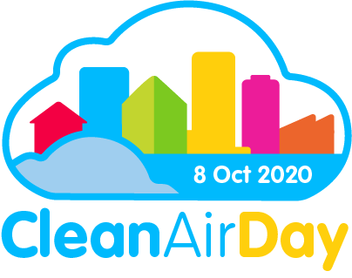

A personal request from Larissa Lockwood, Director of Clean Air
It’s my favourite time of year coming up! But it is a busy time for us at Global Action Plan at Clean Air Day HQ and we need your support now more than ever to make sure Clean Air Day is a success.
This comms pack has been built to help your comms team to support the Clean Air Day campaign mission to:
1) Increase public UNDERSTANDING about air pollution in the UK
2) Drive ENGAGEMENT AND BEHAVIOUR CHANGE linked to air pollution

Last year, more than 3,700 organisations and hundreds of thousands of individuals took part in 614 events across the UK. The campaign generated more than 2,000 media items, and 45,000 social media posts.

This year, we experienced cleaner air and saw massive shifts to low pollution behaviours during the COVID-19 lockdown. Let’s keep up the momentum and keep our air clean.
We all have a part to play in keeping our air clean - together let’s make Oct 8 the cleanest Clean Air Day yet.
Please use the content in this pack to help make a splash on 8 October Clean Air Day 2020.
Larissa Lockwood, Director of Clean Air, Global Action Plan

Clean Air Day 2020
Overview of the day
Every year, air pollution causes up to 36,000 deaths in the UK. The World Health Organisation and the UK Government recognise that air pollution is the largest environmental health risk we face today.
Clean Air Day is the UK's largest air pollution campaign, engaging thousands of people at hundreds of events, and reaching millions more through the media.

This year Clean Air Day is taking place on 8 October 2020 and will be rolled out slightly differently. To keep you, your family, friends and colleagues safe, we’ve updated the campaign to be more virtual. We are hosting our first ever virtual event, Clean Air Day LIVE, which is kicking off from 10am.

We cannot wait to celebrate Clean Air Day 2020 and hope you are too. Make sure you're ready to play your part in this year's campaign and let’s make October 8 the cleanest Clean Air Day yet!

Our two main asks
- Mention Clean Air Day & Clean Air Day LIVE in your newsletters in the week leading up to 8 October.
- Schedule social media posts ahead of and on Clean Air Day, to help us get #CleanAirDay trending and launch on social media with a bang!

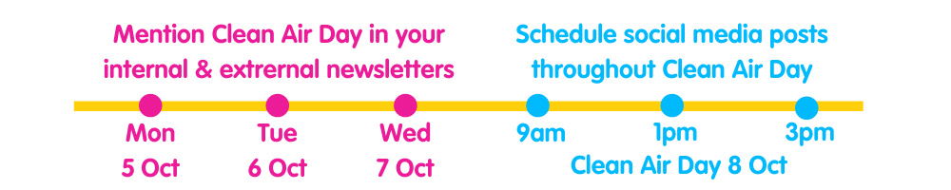
1) Mention us in your newsletters in the build-up to Clean Air Day
If you are sending out a newsletter this week be that internal or external, please do mention Clean Air Day. We have listed out some key element for you to include below.
- The date - 8 October
- Background information on Clean Air Day
- Your involvement in Clean Air Day
- Key resources
- Registration link to Clean Air Day LIVE
- Calls to action
Here is an example script
Clean Air Day is just around the corner – this Thursday 8 October!
Clean Air Day is the UK's largest air pollution campaign which is organised by charity Global Action Plan. The campaign helps to drive a positive shift in public knowledge and action; and is a chance to find out more about air pollution, share information, and make the air cleaner and healthier for everyone.
[INSERT NAME OF ORGANISATION] are really excited to be taking part in the campaign and encourage you all to [INCLUDE ASKS OF STAKEHOLDERS E.G. WORK FROM HOME, WALK/CYCLE TO SCHOOL].
It’s not too late to get involved. Here are all the amazing ways you can support this year’s campaign and play your part in reducing air pollution:
- Increase your understanding about air pollution:
  - Attend Clean Air Day LIVE, their first ever virtual event, which will be broadcast from the Clean Air Day website from 10am, 8 October.
  - Calculate your impact on air pollution by using the UK’s first Personal Air Pollution Calculator and share your results.
  - Read up on the most up-to-date information about air pollution on the Clean Air Hub.
- Help drive engagement to the campaign by supporting on social media and sharing their free resources:
  - Share the Clean Air for Schools Framework, a free online tool which offers schools bespoke actions for tackling air pollution with your local school or council.
  - Check out and share their free Clean Air Day resources.
  - Pledge to leave the car at home and walk or cycle instead; work from home or write to your politicians to tell them what you are doing to tackle air pollution and ask them to play their part.
Here are some newsletter ready graphics
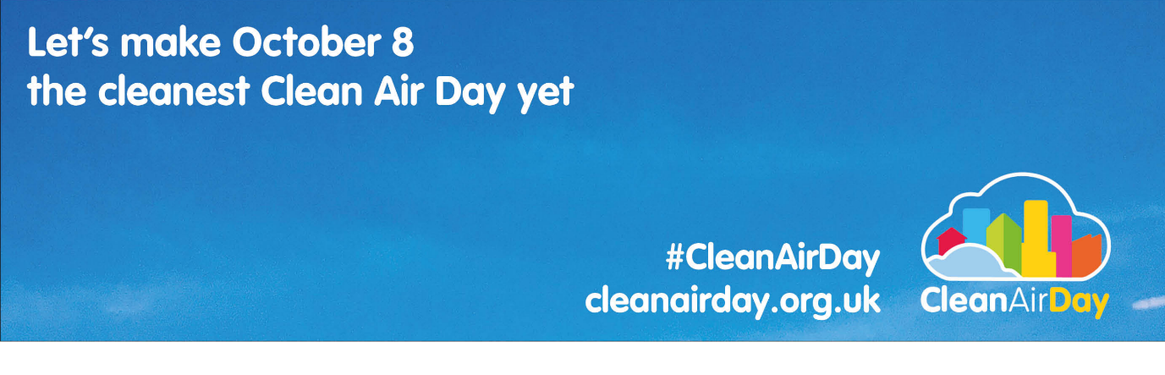
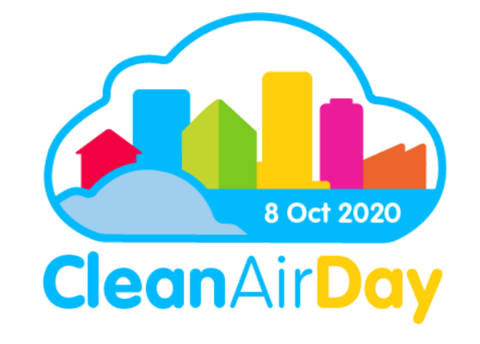
2) Schedule social media posts throughout Clean Air Day
We believe we are going to have the greatest impact if you can post or schedule social media posts for Clean Air Day itself and get #CleanAirDay trending.
Scheduling a post for 9am Thursday morning will allow us all to kick off Clean Air Day with a social media bang, helping us achieve our first aim UNDERSTANDING. Whilst supporting posts throughout the day will help us maintain this momentum and achieve or second goal ENGAGEMENT and BEHAVIOUR CHANGE.
Key accounts:
Clean Air Day
Twitter & Facebook: @CleanAirDayUK
Global Action Plan (co-ordinators of Clean Air Day):
Twitter: @globalactplan
Instagram & Facebook: @globalactionplan
Suggested posts:
1) Increase public understanding of air pollution:
“Did you know” posts:
- Did you know, primary and nursery school children can be exposed to 15% more pollution compared to adults when walking on busy roads due to them being closer to exhaust fumes? #CleanAirDay @CleanAirDayUK
- Did you know, the most polluted place to be on the roads is often inside a vehicle as they gather pollution? Car drivers can be exposed to twice as much air pollution as pedestrians or cyclists. #CleanAirDay @CleanAirDayUK
- Did you know, 25% of all car journeys in the UK are under two miles? If all these car journeys were walked instead it would save £16 million in fuel and the population would burn an additional 3.6 billion calories. #CleanAirDay @CleanAirDayUK
- Did you know, the total health cost to the UK from cars and vans is £6 billion each year with 90% coming from diesel vehicles? #CleanAirDay @CleanAirDayUK
- Did you know, the benefits of exercise normally outweigh the harm from air pollution you may be exposed to? But if you suffer from heart and lung disease, avoid strenuous exercise outdoors on very high pollution days. #CleanAirDay @CleanAirDayUK
- Did you know, if employers support greater remote working, as many as 1 in 5 car journeys driven for business purposes could be eliminated, equating to 11 billion miles saved per year? #CleanAirDay @CleanAirDayUK
Clean Air Hub posts:
- Wise up on #airpollution on #CleanAirDay: visit and share cleanairhub.org.uk
- #AirPollution could be damaging you and your family’s health. Today on #CleanAirDay find out how to protect your health at cleanairhub.org.uk
- There are many sources of outdoor #airpollution including road transport, energy generation, industry, open fires & stoves and agriculture. On #CleanAirDay, wise up on air pollution by heading to cleanairhub.org.uk
2) Drive engagement and behaviour change:
Behaviour change posts:
- Play your part this #CleanAirDay: leave the car at home
- Play your part this Clean Air Day: Use quieter streets when you’re on a bike or on foot to avoid polluted main roads
- Play your part this #CleanAirDay: talk to your local Councillors and MP about improving air pollution in your area
- Its #CleanAirDay We are extremely proud to be official partners of Clean Air Day this year in this year! Together let’s make this the cleanest Clean Air Day yet. #BuildBackBetter #AirPollution www.cleanairday.org.uk @CleanAirDay @GlobalActionPlan
- Our air pollution crisis is solvable. If we all drive less, we will cut down the pollution
Clean Air Day LIVE posts:
- Its #CleanAirDay. We are tuning into #CleanAirDayLive today! It kicks off from 10am and it’s not too late to join. Check out the line up to find an event that interests you: www.cleanairday.org.uk/clean-air-day-live
Personal Air Pollution Calculator posts:
- Its #CleanAirDay! If you haven’t already check out the Air Pollution Calculator to better understand your personal impact on #AirPollution. Together let’s make this the cleanest Clean Air Day yet. #BuildBackCleanerAir #AirPollution https://calculator.cleanairhub.org.uk/quiz
- Today is #CleanAirDay! It is easier to maintain a habit than to create a new one, so let’s work together to keep doing the lockdown behaviours that contributed to cleaner air. #BuildBackCleanerAir
- #CleanAirDay is here! Taking responsibility for your role on #cleanair encourages a sense of ownership of the issue as well as recognition of the potential impact of poor air quality on you and your family
Personal pledge posts:
- Today is #CleanAirDay – I pledge to play my part in reducing #airpollution by walking and cycling more.
- Today is #CleanAirDay - I pledge play my part in reducing #airpollution by working from home more often.
- Today is #CleanAirDay – I pledge to play my part in reducing #airpollution by asking my local Councillors and MP about how I can support my local air pollution plan.
- Today is #CleanAirDay – I pledge to play my part in reducing #airpollution by avoiding using wood burning stoves and open fires.
Infographics:
Rectangular 1024 x 512: Facebook, Twitter & LinkedIn
Square 1024x 1024: Instagram
